**Users and Access:**

|  |  |
| --- | --- |
| **User Name** | **Password** |
| cust1 | cust1 |



Provide access to Customer on below tables only



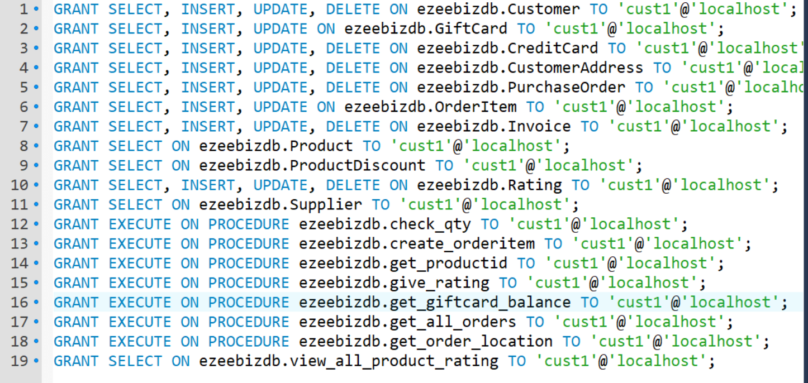

|  |  |
| --- | --- |
| **User Name** | **Password** |
| supp1 | supp1 |



Provide access to Supplier on below tables only



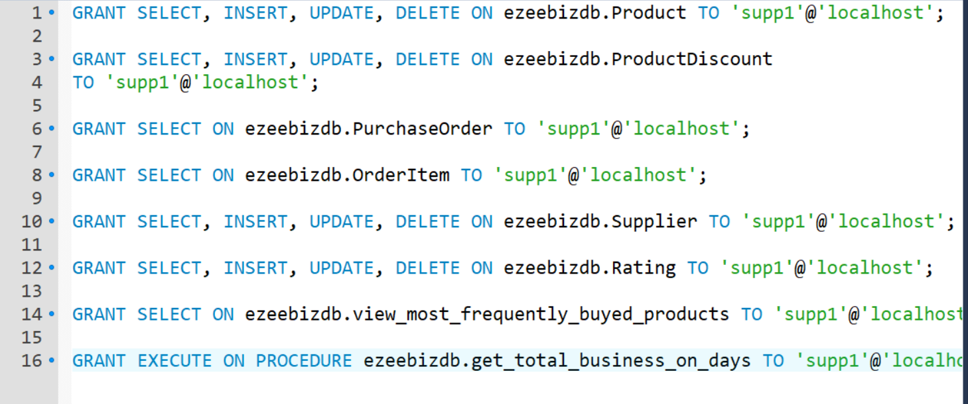

|  |  |
| --- | --- |
| **User Name** | **Password** |
| whouse1 | whouse1 |



Provide access to Warehouse user on below tables only



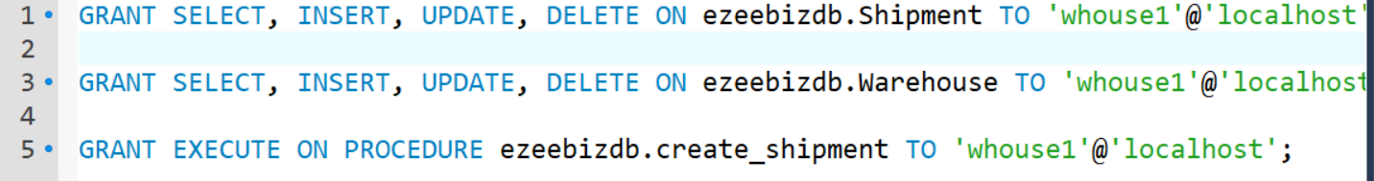

|  |  |
| --- | --- |
| **User Name** | **Password** |
| fedex | fedex1 |



Provide access to FEDEX1user on below tables only



